COP 4710 Team Project
Final Report

Sheng Rao, U9568-1295
Quan Nguyen, U9326-4250
Joshua Rivas-Ferreira, U2535-3287
Nathaniel Navarro, U1215-7787
Spencer Durell, U6238-7873

Organization Overview:
We will be building our database for a banking organization. This organization will serve the banking needs of customers, who will be conducting their transactions at physical bank locations staffed by tellers and bank managers. The main purpose of the database is to track the transactions and current balance of customers’ accounts, with a secondary purpose of tracking the staffing and transaction metrics of individual bank locations. The customer will be able to view their account balance, while the tellers will process transactions to/from/between accounts (deposit/withdraw/transfer). The database will also keep track of management and employee responsibilities.

Business Rules:

Sources used for Ideas:
https://www.geeksforgeeks.org/er-diagram-of-bank-management-system/
http://ijeais.org/wp-content/uploads/2024/4/IJAER240404.pdf
https://www.scaler.com/topics/er-diagram-for-bank-database/

Note: Business rules defining relationships will have entities bolded and underlined and the relationship italicized

- An Account is an entity with attributes of AccountID (Int), AccountType (String), Balance (Float), AccountOpened (Date)
- An Account can be owned by many Customers (ex: joint accounts) but must have at least one owner, and a Customer can own many Accounts.
- An Account must belong to a Branch (typically the place it’s opened at).
- A Customer is an entity with attributes of CustomerID (Int, Key), FirstName (String), LastName (String), DateOfBirth (Date), Address (String), SSN (Int)
- A Customer cannot open an Account without a SSN and valid Address with proof of residence, in other words these cannot be NULL.
- A Loan is a subtype of Account and has additional attributes of LoanID (key), InterestRate (Float), LoanTerm (Date) which is the date of the end of the loan, Collateral (String), and Schedule (String) which is the rate of repayment (either monthly, quarterly, biannually, or annually).
- A Loan’s InterestRate must be a positive float value, and its balance must be a negative value (as a calculation of debt)
- A Card is a subtype of Account and has additional attributes of CardNumber (Int), ExpirationDate (Date), PIN (Int) which is the 5-digit code you enter for swipe transactions, and VerifyCode (Int) which is the three additional numbers found on the back of the card that you are constantly asked for in online purchases.
- A Card’s ExpirationDate must be a future date. Cards with past/present ExpirationDates are invalid.
- A Transaction is an entity with attributes of TransactionID (Int, Key), TransactionDate (Date), Amount (Float), and TransactionType (String) which can be used to define categories for further processing.
- Every Transaction is applied to exactly one Account, but an Account can have multiple Transactions.
- A LoanPayment is a subtype of Transaction, with additional attributes of Late (Boolean), Fees (Int) for late payment, InterestAmount (Float), and PrincipalAmount (Float).
- A LoanPayment is made towards a Loan. A Loan can have many LoanPayments and each LoanPayment is associated with exactly one Loan.
- A Branch is an entity with attributes of BranchID (Int, Key), Name (String), Address (String), EmployeeCount (Int, Nullable), and CashOnHand (Int) for the amount of physical money in the Branch’s possession which should be kept above a certain limit and is particularly important for the subtype ATM.
- An ATM is a subtype of Branch, with additional attributes of MachineType (Int), InstallDate (Date), LastMaintenance (Date), and WithdrawalLimit (Int).
- A Branch can facilitate many Transactions, and each Transaction must be tied to exactly one Branch.
- An Employee is an entity with attributes of EmployeeID (Int, Key), FirstName (String), LastName (String), DOB (Date), and Salary (Float).
- A Branch can have many Employees but each Employee works at one Branch
- A Teller is a subtype of Employee, with additional attributes of NotaryID (Int) for the ID of their Notary stamp, LockerID (Int) for the locker that they store their personal effects during work, WindowNumber (Int), and PerformanceReview (Boolean) for whether they are under performance review.
- A Teller can process many Transactions, and each Transaction must be processed by exactly one Teller.
- A Manager is a subtype of Employee, with additional attributes of Title(String), AuditDate (Date) for the date of the last performed Audit at the Branch they are managing, OfficeRoom (String) for the room designation of their office, and Certification (String) for the certification that makes them qualified for wealth management (ex: degree or CPA etc cert)..
- A Manager manages one Branch, and all Branches have at least one Manager, with some (large) branches having multiple managers.
- A Manager supervises many Employees but each Employee must be supervised by one Manager.

ER Diagram:
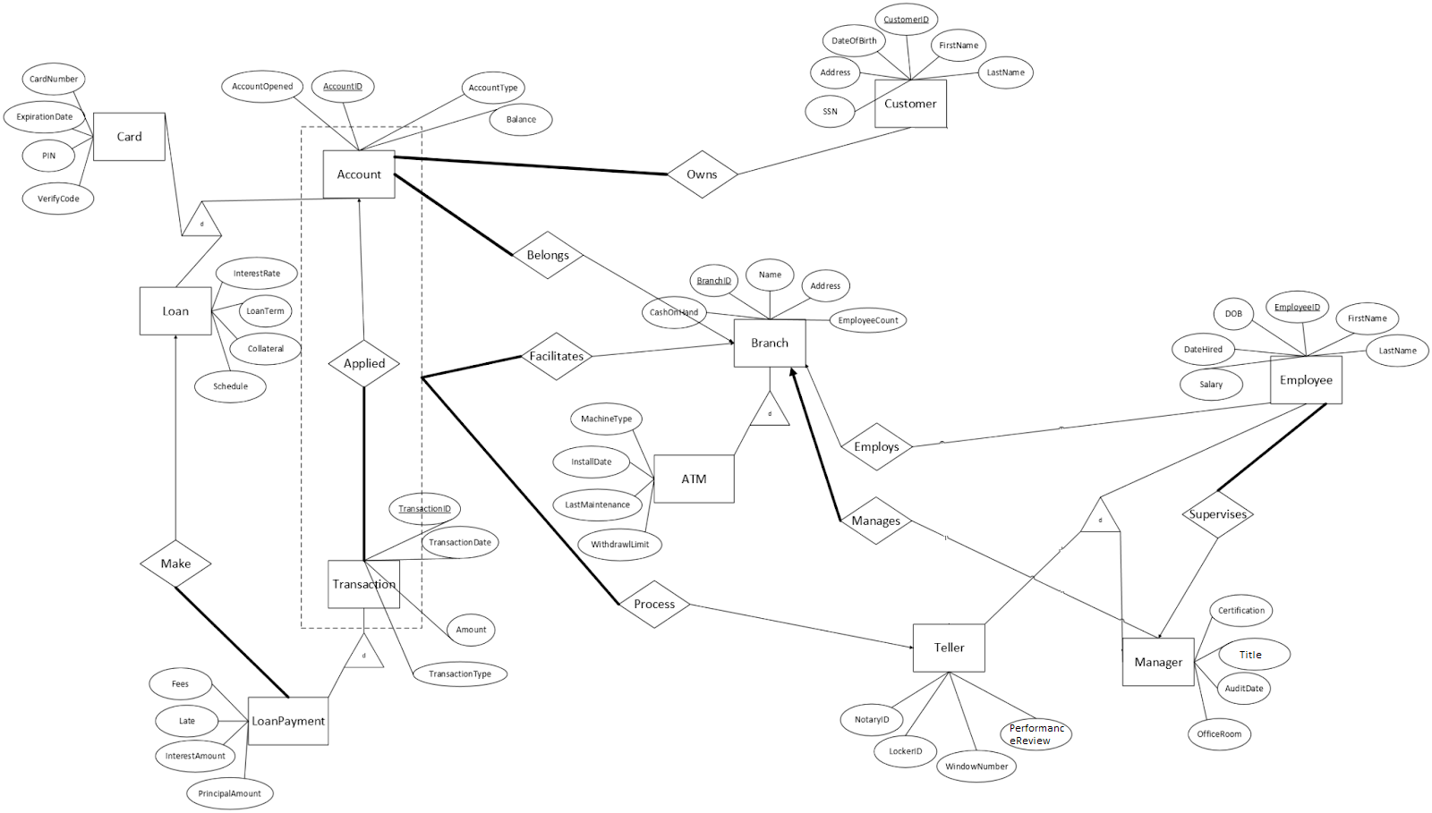

Normalization and DDL statements
Accounts:

The table Accounts has columns that all contain singular values and does not have repeating rows or columns. The above diagram does not show any partial or transitive dependencies, therefore the table is in 3NF.

SQL:
CREATE TABLE Accounts(
AccountID INT PRIMARY KEY,
AccountOpened DATE,
AccountType VARCHAR(100),
Balance DECIMAL(9,2) DEFAULT 0.00,
BranchID INT NOT NULL,
CONSTRAINT Belongs FOREIGN KEY (BranchID) REFERENCES Branches(BranchID)
);

Cards:
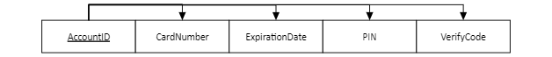

The table Cards has columns that all contain singular values and does not have repeating rows or columns. The above diagram does not show any partial or transitive dependencies, therefore the table is in 3NF.

SQL:
CREATE TABLE Cards(
AccountID INT PRIMARY KEY,
CardNumber BIGINT,
ExpirationDate DATE CHECK (ExpirationDate > CURRENT_DATE),
PIN INT,
VerifyCode INT,
FOREIGN KEY (AccountID) REFERENCES Accounts(AccountID) ON DELETE CASCADE
);

Loans:

The table Loans has columns that all contain singular values and does not have repeating rows or columns. The above diagram does not show any partial or transitive dependencies, therefore the table is in 3NF.

SQL:
CREATE TABLE Loans(
AccountID INT PRIMARY KEY,
InterestRate FLOAT CHECK (InterestRate > 0),
LoanTerm DATE,
Collateral VARCHAR(100),
Schedule VARCHAR(100),
Balance DECIMAL(15, 2) CHECK (Balance < 0),
FOREIGN KEY (AccountID) REFERENCES Accounts(AccountID) ON DELETE CASCADE
);

Employees:

EmployeeID | FirstName | LastName | DOB | Salary | BranchID | ManagerID
… | … | … | … | … | … | …

The above diagram is in 3NF because it has an identified primary key with atomic values, has no repeating groups, and does not have any partial or transitive dependencies.

SQL:
CREATE TABLE Employees (
EmployeeID INT PRIMARY KEY,
FirstName VARCHAR(100) NOT NULL,
LastName VARCHAR(100) NOT NULL,
DOB DATE NOT NULL,
Salary DECIMAL(9,2) DEFAULT 0.00 NOT NULL,
BranchID INT,
ManagerID INT NOT NULL,
FOREIGN KEY (BranchID) REFERENCES Branches,
FOREIGN KEY (ManagerID) REFERENCES Employees(EmployeeID)
);

Tellers:

EmployeeID | NotaryID | LockerID | WindowNumber | PerformanceReview
… | … | … | … | …

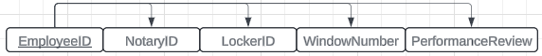
The above diagram is in 3NF because it has an identified primary key with atomic values, has no repeating groups, and does not have any partial or transitive dependencies.

SQL:
CREATE TABLE Tellers (
EmployeeID INT PRIMARY KEY,
NotaryID INT,
LockerID SMALLINT,
WindowNumber SMALLINT,
PerformanceReview BOOLEAN,
FOREIGN KEY (EmployeeID) REFERENCES Employees ON DELETE CASCADE
);

Managers:

EmployeeID | Title | AuditDate | OfficeRoom | Certification | BranchID
… | … | … | … | … | …

The above diagram is in 3NF because it has an identified primary key with atomic values, has no repeating groups, and does not have any partial or transitive dependencies.

SQL:
CREATE TABLE Managers (
EmployeeID INT PRIMARY KEY,
Title VARCHAR(100) NOT NULL,
AuditDate DATE,
OfficeRoom VARCHAR(100),
Certification VARCHAR(100),
BranchID INT NOT NULL,
FOREIGN KEY (EmployeeID) REFERENCES Employees ON DELETE CASCADE,
FOREIGN KEY (BranchID) REFERENCES Branches
);

Transactions:

TransactionID | TransactionDate | Amount | TransactionType | AccountID | BranchID | EmployeeID
… | … | … | … | … | … | …

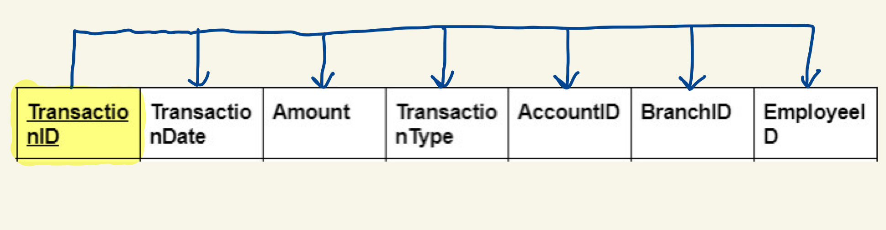

In the Transactions table above, a primary key is defined so all rows are unique, values are atomic, and there are no repeating groups so it passes 1NF. According to the dependency diagram, there aren’t any partial or transitive dependencies, so it also passes 2NF and 3NF. As a result, the table is in 3NF.

PostgreSQL:

CREATE TABLE Transactions (
TransactionID SERIAL PRIMARY KEY,
TransactionDate DATE NOT NULL,
Amount DECIMAL(8, 2) NOT NULL CHECK (amount > 0.00 AND amount <= 250000.00),
TransactionType VARCHAR(100) NOT NULL,
AccountID INT NOT NULL,
BranchID INT NOT NULL,
EmployeeID INT NOT NULL,
FOREIGN KEY (AccountID) REFERENCES Accounts(AccountID),
FOREIGN KEY (BranchID) REFERENCES Branches(BranchID),
FOREIGN KEY (EmployeeID) REFERENCES Employees(EmployeeID)
);

Loan Payments:

TransactionID | Late | Fees | InterestAmount | PrincipalAmount
… | … | … | … | …

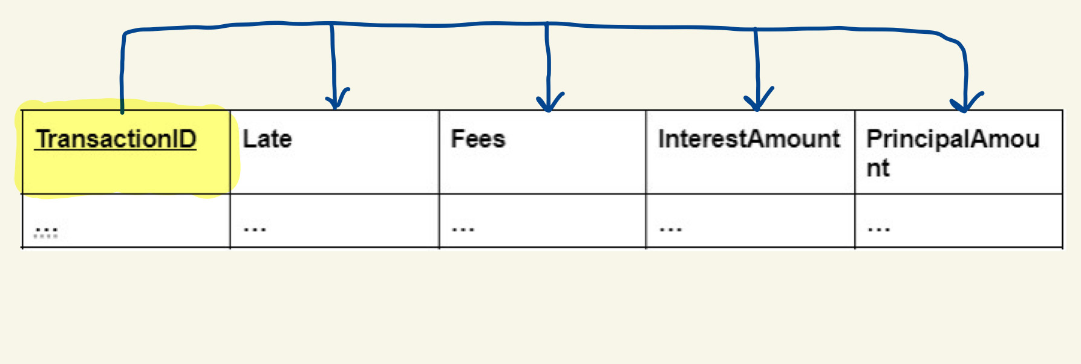

In the Loan Payments table above, a primary key is defined so all rows are unique, values are atomic, and there are no repeating groups so it passes 1NF. According to the dependency diagram, there aren’t any partial or transitive dependencies, so it also passes 2NF and 3NF. As a result, the table is in 3NF.

PostgreSQL:

CREATE TABLE LoanPayments (
TransactionID INT PRIMARY KEY,
LoanID
Late BOOLEAN NOT NULL,
Fees DECIMAL(7, 2) DEFAULT 0.00,
InterestAmount DECIMAL(7, 2) NOT NULL,
PrincipalAmount DECIMAL(9, 2) NOT NULL,
FOREIGN KEY (TransactionID) REFERENCES Transactions(TransactionID) ON DELETE CASCADE
);

Branches:

BranchID | CashOnHand | Name | Address | EmployeeCount
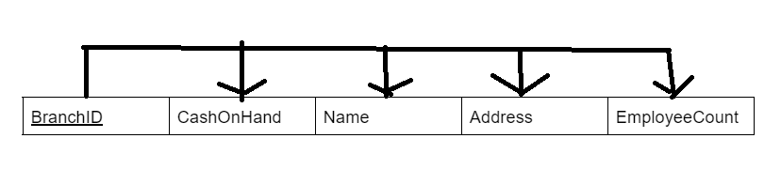
The Branches table is in 3NF. The primary key is defined meaning all rows are unique, its values are atomic, and there are no repeating groups; therefore it is in 1NF. The dependency diagram also shows that there are no partial or transitive dependencies, meaning it is in 2NF and 3NF. Therefore, the table is at least 3NF.

SQL:
CREATE TABLE Branches(
BranchID INT PRIMARY KEY,
CashOnHand DECIMAL(12,2) DEFAULT 0.00,
BranchName VARCHAR(100),
Address VARCHAR(100),
EmployeeCount INT
);

ATMs:

BranchID | MachineType | InstallDate | LastMaintenance | WithdrawalLimit

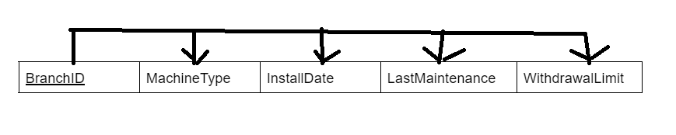
The ATMs table is in 3NF. The primary key is defined meaning all rows are unique, its values are atomic, and there are no repeating groups; therefore it is in 1NF. The dependency diagram also shows that there are no partial or transitive dependencies, meaning it is in 2NF and 3NF. Therefore, the table is at least 3NF.

SQL:
CREATE TABLE ATM(
BranchID INT PRIMARY KEY,
MachineType VARCHAR(100),
InstallDate DATE,
LastMaintenance DATE,
WithdrawalLimit DECIMAL,
FOREIGN KEY (BranchID) REFERENCES Branches(BranchID) ON DELETE CASCADE
);

Customers:
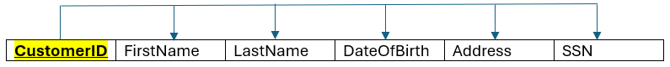
In the Customer table above, a primary key is defined so all rows are unique, values are atomic, and there are no repeating groups so it passes 1NF. According to the dependency diagram, there aren’t any partial or transitive dependencies, so it also passes 2NF and 3NF. As a result, the table is at least in 3NF
SQL:
CREATE TABLE customers (
CustomerID SERIAL PRIMARY KEY,
FirstName VARCHAR(50) NOT NULL,
LastName VARCHAR(50) NOT NULL,
DateOfBirth DATE NOT NULL,
Address TEXT NOT NULL,
SSN CHAR(11) NOT NULL UNIQUE
);

Customer Accounts / Owns:
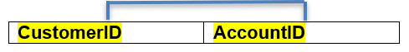

In the Customer Accounts / Owns table above, a primary key is defined so all rows are unique, values are atomic, and there are no repeating groups so it passes 1NF. According to the dependency diagram, there aren’t any partial or transitive dependencies, so it also passes 2NF and 3NF. As a result, the table is at least in 3NF
SQL:
CREATE TABLE Owns (
CustomerID INT,
AccountID INT,
PRIMARY KEY (CustomerID, AccountID),
FOREIGN KEY (CustomerID) REFERENCES Customers(CustomerID) ON DELETE CASCADE,
FOREIGN KEY (AccountID) REFERENCES Accounts(AccountID) ON DELETE CASCADE
);

Data Dictionary:

Table Name | Attribute Name | Contents | Type | Format | Range | Required | PK OR FK | FK REFERENCED TABLE
Accounts | AccountID | Account ID | INT |  |  | Y | PK
 | AccountOpened | Opened date | DATE | YYYY-MM-DD
 | AccountType | Type of account | VARCHAR(100)
 | Balance | Amount in account | DECIMAL(9,2)
 | BranchID | Branch ID | INT |  |  | Y | FK | Branches
Cards | AccountID | Account ID | INT |  |  | Y | PK, FK | Accounts
 | CardNumber | Number on card | INT
 | ExpirationDate | Expiration on card | DATE | YYYY-MM-DD | > CURRENT_DATE
 | PIN | PIN for card | INT
 | VerifyCode | Security code on card | INT | XXX
Loans | AccountID | Account ID | INT |  |  | Y | PK, FK | Accounts
 | InterestRate | Interest rate on loan | DECIMAL(9,2) | XX.XX | > 0
 | LoanTerm | Date loan ends | DATE | YYYY-MM-DD
 | Collateral | Item used as collateral | VARCHAR(100)
 | Schedule | How often payments made | VARCHAR(100)
 | Balance | Amount left on loan | DECIMAL(9,2) |  | < 0
Employees | EmployeeID | Identifier of Employee | INT | ######## |  | Y | PK
 | FirstName | First name | VARCHAR(100) | XXXXXXX.. |  | Y
 | LastName | Last name | VARCHAR(100) | XXXXXXX.. |  | Y
 | DOB | Date of Birth | DATE | YYYY-MM-DD |  | Y
 | Salary | Yearly Salary | DECIMAL(9, 2) | #######.## |  | Y
 | BranchID | Identifier of Branch they work at | INT | ######## |  | N | FK | Branches
 | ManagerID | Identifier of the employee’s supervisor | INT | ######## |  | Y | FK | Managers (EmployeeID)
Tellers | EmployeeID | Identifier of Teller | INT | ######## |  | Y | PK, FK | Employees
 | NotaryID | Identifier of their unique Notary Stamp | INT | ######## |  | N
 | LockerID | Identifier of their assigned locker for personal effects | SMALLINT | ## |  | N
 | WindowNumber | Identifier of the Window they work at | SMALLINT | ## |  | N
 | PerformanceReview | True/False whether they are under performance review | BOOLEAN | True/False |  | N
Managers | EmployeeID | Identifier of Manager (Employee) | INT | ###### |  | Y | PK, FK | Employees
 | Title | Specific Job Title | VARCHAR(100) | XXXXXXX.. |  | Y
 | AuditDate | Date of last performed internal audit | DATE | YYYY-MM-DD |  | N
 | OfficeRoom | Designation of room of their office | VARCHAR(100) | XXXXXXX.. |  | N
 | Certification | Qualification used for their wealth management authority (degree, CPA cert, etc) | VARCHAR(100) | XXXXXXX.. |  | N
 | BranchID | Identifyer of the Branch that they manage | INT | ###### |  | Y | FK | Branches
Transactions | TransactionID | Transaction ID | INT | ###### | NA | Y | PK
 | TransactionDate | Date of transaction | DATE | YYYY-MM-DD | NA | Y
 | Amount | Amount of money transferred | DECIMAL(8, 2) | ######.## | 0.01-250000.00 | Y
 | TransactionType | Type of transaction | VARCHAR(100) | XXXXXXX… | NA | Y
 | AccountID | Account ID | INT | ######## | NA | Y | FK | Accounts
 | BranchID | Branch ID | INT | ### | NA | Y | FK | Branches
 | EmployeeID | Employee ID | INT | ###### | NA | Y | FK | Employees
Loan Payments | TransactionID | Transaction ID | INT | ### | NA | Y | PK, FK | Transactions
 | Late | Indicates whether loan is overdue | BOOLEAN | TRUE/FALSE | NA | Y
 | Fees | Fees associated with payment | DECIMAL(7, 2) | #####.## | NA | N
 | InterestAmount | Amount of interest charged | DECIMAL(7, 2) | #####.## | NA | Y
 | PrincipalAmount | Amount of payment that reduces the loan’s principal | DECIMAL(9, 2) | #######.## | NA | Y
Branches | BranchID | Branch ID | INT |  |  | Y | PK
 | CashOnHand | Amount of Cash stored at the bank currently | DECIMAL(11,2) | ###.## |  | Y
 | Name | Name of Branch | VARCHAR(100) |  |  | Y
 | Address | Address of Branch | VARCHAR(100) |  |  | Y
 | EmployeeCount | Numbers of Employees Employed at a Branch | INT
ATMs | BranchID | Branch ID | INT |  |  | Y | PK, FK
 | MachineType | Type of Machine | VARCHAR(100) |  |  | Y
 | InstallDate | When ATM was Installed | DATE | YYYY-MM-DD |  | Y
 | LastMaintenance | When ATM last had Maintenance | DATE | YYYY-MM-DD |  | Y
 | WithdrawalLimit | Max Cash able to be withdrawn | DECIMAL(9,2) | ####.## |  | Y
Customers | CustomerID | Identifier of Customer | INT |  |  | Y | PK
 | FirstName | Customer’s first name | VARCHAR(100) |  |  | Y
 | LastName | Customer’s last name | VARCHAR(100) |  |  | Y
 | DateOfBirth | Customer’s legal date of birth | DATE | YYYY-MM-DD |  | Y
 | Address | Customer’s address | TEXT |  |  | Y
 | SSN | Social Security Number | DECIMAL(9,0) | XXX-XX-XXXX |  | Y
Customer Accounts | CustomerID | Identifier of the Customer owning the Account | INT |  |  | Y | PK, FK | Customers (CustomerID)
 | AccountID | Identifier of the Account being owned by the Customer | INT |  |  | Y | PK, FK | Accounts (AccountID)

Table Entries

Name | Number of Entries
Branches | 20
ATM | 10
Employees | 20
Managers | 10
Tellers | 10
Accounts | 20
Cards | 10
Loans | 10
Transactions | 21
LoanPayments | 10
Customers | 10
Owns | 20

Interesting Updates & Results
UPDATE LoanPayments
SET Fees = Fees * 1.20
WHERE Late = TRUE AND PrincipalAmount > 1000.00;
This update is interesting because it compounds late fees by 20%, a simple and efficient way to implement automated late fee compounding on all accounts with a single instruction. More specific qualifiers can be added to the WHERE conditional if necessary.

UPDATE Transactions
SET Amount = Amount + 100.00
WHERE AccountID = 1 AND TransactionType = 'Deposit';

This update is interesting because it adds 100 to all deposit transactions for accountID 1, which seems like a fix for some bug or mistake that caused all records from this account to underreport by 100.

UPDATE Transactions
SET Amount = Amount * 2.00
WHERE BranchID = 1 AND AccountID < 11;

This update is interesting because it seems like evidence of embezzlement. A bad actor is perhaps using the intersection of branchID and low accountID (which typically is given to management) to double their money without using specific names or accountIDs.

UPDATE Transactions
SET Amount = 5000.00
WHERE TransactionType = 'Withdrawal' AND Amount > 5000.00;

This update is interesting because it’s a blanket operation that works on all transactions that are withdrawals and of an amount larger than 5000. The result is that all withdrawal transactions over 5000 are capped to 5000 instead.

Constraints Check Results
-- Integrity
INSERT INTO Branches (BranchID, CashOnHand, BranchName, Address, EmployeeCount) VALUES
(1, 30000.00, 'Dupe', 'Dupe', 10);

This query results in an error: ERROR: Key (branchid)=(1) already exists.duplicate key value violates unique constraint "branches_pkey", since you can’t have two entries with the same primary key.

-- Check
UPDATE Cards
SET expirationdate = '2023-06-27'
WHERE accountid = 1;

This query results in an error: ERROR: Failing row contains (1, 5579747144710460, 2023-06-27, 1992, 505).new row for relation "cards" violates check constraint "cards_expirationdate_check", since the expiration date is in the past instead of the future.

UPDATE Loans
SET balance = 100
WHERE accountid = 11;

This query results in an error: ERROR: Failing row contains (11, 34.01, 2026-03-26, Vehicles, Biweekly, 100.00).new row for relation "loans" violates check constraint "loans_balance_check", because loan balances have to be negative, not positive.

UPDATE Loans
SET interestrate = -10.00
WHERE accountid = 11;

This query results in an error: ERROR: Failing row contains (11, -10, 2026-03-26, Vehicles, Biweekly, -1500.00).new row for relation "loans" violates check constraint "loans_interestrate_check", because interest rates have to be positive, not negative.

UPDATE Transactions
SET Amount = 500000.00
WHERE TransactionID = 15;

This query results in an error: ERROR: Failing row contains (15, 2025-10-30, 500000.00, Deposit, 4, 10, 9010).new row for relation "transactions" violates check constraint "transactions_amount_check", since amounts have to be below 250,000 which 500,000 isn’t.

-- Referential
INSERT INTO ATM (BranchID, MachineType, InstallDate, LastMaintenance, WithdrawalLimit) VALUES
(99, 'BadFK', '1990-01-01', '1990-01-01', 5000.00);

This query results in an error: ERROR: Key (branchid)=(99) is not present in table "branches".insert or update on table "atm" violates foreign key constraint "atm_branchid_fkey", because the FK being referenced doesn’t exist in the Branches table.

INSERT INTO Owns (CustomerID, AccountID)
VALUES (999, 1);

This query results in an error: ERROR: Key (customerid)=(999) is not present in table "customers".insert or update on table "owns" violates foreign key constraint "owns_customerid_fkey", because the FK being referenced (999) doesn’t exist in the Customers table.

INSERT INTO Owns (CustomerID, AccountID)
VALUES (101, 999);

This query results in an error: ERROR: Key (accountid)=(999) is not present in table "accounts".insert or update on table "owns" violates foreign key constraint "owns_accountid_fkey", because the FK being referenced (999) doesn’t exist in the Accounts table.

-- Not Null
INSERT INTO Branches (BranchID, CashOnHand, BranchName, Address, EmployeeCount) VALUES
(NULL, 25000.00, 'Error', 'Error', 10);

This query results in an error: ERROR: Failing row contains (null, 25000.00, Error, Error, 10).null value in column "branchid" of relation "branches" violates not-null constraint, because the branchID cannot be NULL by constraint as well as regular dbms format.

INSERT INTO Customers (CustomerID, FirstName, LastName, DateOfBirth, SSN, Address)
VALUES (111, NULL, 'NullName', '1990-01-01', '111-22-3333', '789 Willow St, Lincoln, IL');

This query results in an error: ERROR: Failing row contains (111, null, NullName, 1990-01-01, 789 Willow St, Lincoln, IL, 111-22-3333).null value in column "firstname" of relation "customers" violates not-null constraint, because that constraint requires that column to be not null.

INSERT INTO LoanPayments (TransactionID, Late, Fees, InterestAmount, PrincipalAmount)
VALUES
(1, FALSE, 100.00, 29.32, NULL);

This query results in an error: ERROR: Failing row contains (1, f, 100.00, 29.32, null).null value in column "principalamount" of relation "loanpayments" violates not-null constraint, because the principalamount being inserted is null, which violates the constraint.

Queries & Results
-- (Aggregation) Find the amount of accounts associated with each branch. List them in descending order and display total balance across all accounts
SELECT branches.branchname,
COUNT(*) AS accounts,
SUM(accounts.balance) AS balance_sum
FROM Accounts
JOIN branches on accounts.branchid = branches.branchid
GROUP BY
branches.branchname
ORDER BY
accounts DESC;

This query results in the table:
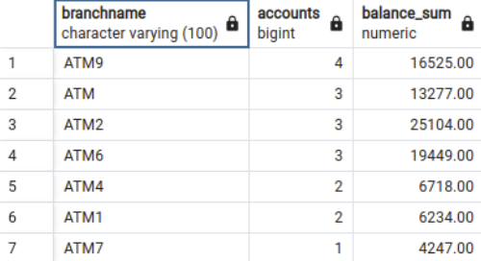
Plus more rows that are too much for the window to display.

-- (Aggregation, Subquery) Find branches that have average balances higher than the average branch of overall accounts
SELECT branches.branchname,
AVG(balance) AS average_balance
FROM Accounts
JOIN branches on accounts.branchid = branches.branchid
WHERE
accounts.balance > (SELECT AVG(accounts.balance) FROM accounts)
GROUP BY
branches.branchname
ORDER BY
average_balance DESC;

This query results in the table:
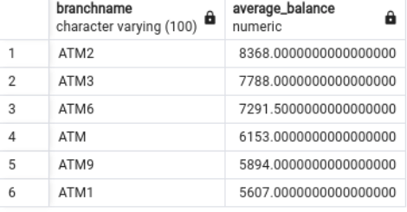

-- (Aggregation, Subquery) We want to find the average salary of tellers at each branch (including branches with no tellers), ordered from highest to lowest.
SELECT
b.BranchName,
ROUND(AVG(ts.Salary),2) AS av
FROM Branches AS b LEFT JOIN (
SELECT
e.EmployeeID,
e.BranchID,
e.Salary
FROM Employees AS e JOIN Tellers AS t
ON e.EmployeeID = t.EmployeeID
) AS ts ON b.BranchID = ts.BranchID
GROUP BY b.BranchName
ORDER BY av DESC NULLS LAST;

This query results in the table:
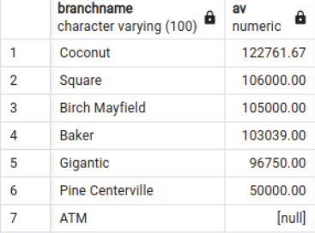

-- We want to find the names of Managers born before the year 1964, ordered by their DOB in descending order.
SELECT
FirstName,
LastName,
DOB
FROM Employees AS e JOIN Managers AS m
ON e.EmployeeID = m.EmployeeID
WHERE DOB < '1964-01-01'
ORDER BY DOB DESC;

This query results in the table:
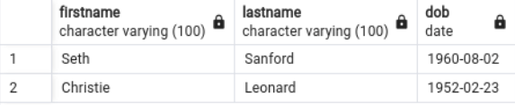

-- (Subquery) Get total withdrawals from ATMs that have been used this year
SELECT Branches.BranchName, Branches.Address, (
SELECT SUM(Transactions.Amount)
FROM Transactions
WHERE Transactions.BranchID = Branches.BranchID
AND Transactions.TransactionType = 'Withdrawal'
AND Transactions.TransactionDate >= '2024-01-01'
) AS TotalWithdrawals
FROM Branches
JOIN ATM ON Branches.BranchID = ATM.BranchID
WHERE ATM.BranchID IN (
SELECT DISTINCT Transactions.BranchID
FROM Transactions
WHERE Transactions.TransactionType = 'Withdrawal'
AND Transactions.TransactionDate >= '2024-01-01'
AND Transactions.Amount > 500
)
ORDER BY TotalWithdrawals DESC;

This query results in the table:
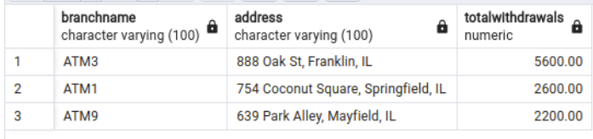

-- (Aggregation) Get Addresses with no ATM installed, just a Bank
SELECT Branches.Address
FROM Branches
LEFT JOIN ATM ON ATM.BranchID = Branches.BranchID
GROUP BY Branches.Address
HAVING COUNT(ATM.BranchID) = 0;

This query results in the table:
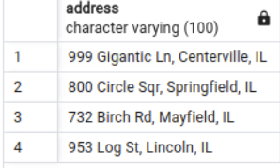

-- (Aggregation) Get the monthly transaction count and total amount for each branch
SELECT
B.BranchID,
B.BranchName,
date_trunc('month', T.TransactionDate)::DATE AS Month,
COUNT(T.TransactionID) AS TransactionCount,
SUM(T.Amount) AS TotalTransactionAmount
FROM
Transactions T
JOIN
Branches B ON T.BranchID = B.BranchID
GROUP BY
B.BranchID, Month
ORDER BY
Month, B.BranchID;

This query results in the table:
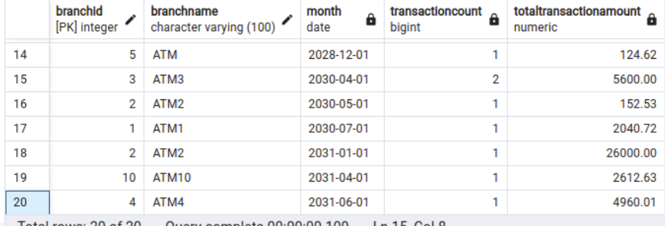
It’s pretty basic since the transactions table is pretty sparse spread over the large time frame, but you can see it’s aggregating correctly on 04-2030

-- (3+, Aggregation) Get the remaining balance left on each loan, along with associated customer info, and list them in descending order
SELECT
C.FirstName,
C.LastName,
C.SSN,
L.AccountID,
L.Balance,
SUM(LP.PrincipalAmount + LP.InterestAmount) AS TotalLoanPayment,
(SUM(LP.PrincipalAmount + LP.InterestAmount) + L.Balance) AS RemainingBalance
FROM
LoanPayments LP
JOIN
Loans L ON LP.TransactionID = L.AccountID
JOIN
Owns O ON L.AccountID = O.AccountID
JOIN
Customers C ON O.CustomerID = C.CustomerID
GROUP BY
L.AccountID, L.Balance, C.FirstName, C.LastName, C.SSN
ORDER BY
RemainingBalance DESC;

This query results in the table:
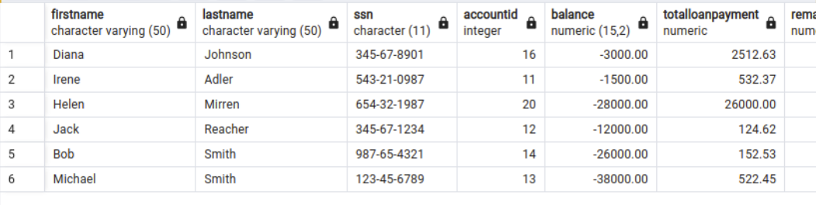

-- (Subquery) Find customers with more than one account
SELECT
C.FirstName,
C.LastName,
COUNT(o.AccountID) AS NumberOfAccounts
FROM Customers C
JOIN
Owns O ON C.CustomerID = O.CustomerID
GROUP BY C.CustomerID
HAVING COUNT(O.AccountID) > 1;

This query results in the table:
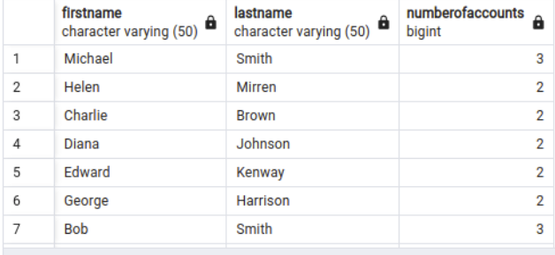

-- (3+) Get customers with account balances and account types
SELECT
C.FirstName,
C.LastName,
A.AccountType,
A.Balance
FROM Customers C
JOIN
Owns O ON C.CustomerID = O.CustomerID
JOIN
Accounts A ON O.AccountID = A.AccountID;

This query results in the table: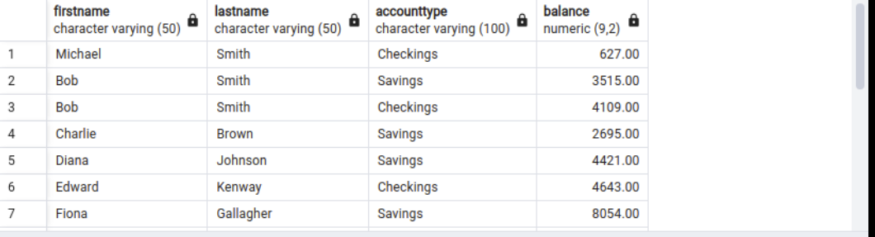
With more rows not displayed in the window but existing downward.

